# Before you collaborate

**Template**

## A little bit of preparation goes a long way with this session. Here’s what you need to do to get going.

### 10 minutes

# 1

**Define your problem statement**

## What problem are you trying to solve? Frame your problem as a How Might We statement. This will be the focus of your brainstorm.

**5 minutes**

# 2

**Brainstorm**

## Write down any ideas that come to mind that address your problem statement.

### 10 minutes

**3**

# Group ideas

## Take turns sharing your ideas while clustering similar or related notes as you go. In the last 10 minutes, give each cluster a sentence-like label. If a cluster is bigger than six sticky notes, try and see if you and break it up into smaller sub-groups.

**20 minutes**

**TIP**

You can select a sticky note and hit the pencil [switch to sketch] icon to start drawing!

## which are feasible.

be on the same page about what's important moving

ideas on this grid to determine which ideas are important and

**4**

**Prioritize**

Your team should all forward. Place your

# After you collaborate

You can export the mural as an image or pdf to share with members of your company who might find it helpful.

# Quick add-ons

#### Share the mural

**PROBLEM**

**The problem is to identify the cause of flight delay and to predict it’s future delays.How to predict the delays?**

1. **Team gathering**

**Brainstorm**

**& idea prioritization**

Use this template in your own brainstorming sessions so your team can unleash their imagination and start shaping concepts even if you're not sitting in the same room.

Define who should participate in the session and send an

#### Mariya Anthony

#### Visuvasammal.S

**Darsheta.D**

Performing machine learning algorithms

#### Mary Rajam.A

Using Weather condition build the model

**Anitha.R**

Knowing the delays improve the customer trust

What

Preprocess the dataset

**TIP**

Add customizable tags to sticky notes to make it easier to find, browse, organize, and categorize important ideas as themes within your mural.

**A**

**Share a view link** to the mural with stakeholders to keep them in the loop about the outcomes of the session.

invite. Share relevant information or pre-work ahead.

#### Set the goal

Think about the problem you'll be focusing on solving in the brainstorming session.

#### Learn how to use the facilitation tools

Use the Facilitation Superpowers to run a happy and productive session.

**10 minutes** to prepare

**1 hour** to collaborate

**2-8 people** recommended

#### [Open article](https://support.mural.co/en/articles/2113740-facilitation-superpowers)

. Data collection using internet

Develop the model

Using the model,it predicts the delay

Preprocess the data

Create web page

Web page displays the excepted time of flight delay

Ask flight details

Passenger will plan according to the flight delay

To built the Model using ML

Predict the delays of flight

Reduce the customer dissatisfaction

Collect the dataset of flight details in internet

Create Web pages for user interaction

opkabgppppppppfind the reason of flight delay

Passenger will get to know about the delay

Get the dataset and do ML algorithms

Passengers can track their flight

Create a webpage ,where user can check the delays

How to get a refund or flight compensation

Analyse the results of each model

Use the effective model for prediction

Display the flight details

Caused the Flight Delay

Closed runway

Equipment malfunction

Building the model

Deliver the delay reason to the passenger

Is more information available on the causes of delays and cancellations?

Airplane cleaning ,air traffic delay

Bad Weather

Using ML and create web pages

**B Export the mural**

Export a copy of the mural as a PNG or PDF to attach to emails, include in slides, or save in your drive.

# Keep moving forward

Develop the model using decision tree ML algorithm

#### Strategy blueprint

Define the components of a new idea or strategy.

[**Open the template**](https://app.mural.co/template/e95f612a-f72a-4772-bc48-545aaa04e0c9/984865a6-0a96-4472-a48d-47639307b3ca)

# Key rules of brainstorming

To run an smooth and productive session

**Customer experience journey map**

Understand customer needs, motivations, and obstacles for an experience.

**20 minutes**

**Importance**

If each of these tasks could get done without any difficulty or cost, which would have the most positive impact?

Departure and arrival time of flights

Air traffic problem,destination and boarding places

#### [Open the template](https://app.mural.co/template/b7114010-3a67-4d63-a51d-6f2cedc9633f/c1b465ab-57af-4624-8faf-ebb312edc0eb)

Stay in topic. Defer judgment.

Encourage wild ideas. Listen to others.

#### Strengths, weaknesses, opportunities & threats

Train and test the model

Check the flight delays

Identify strengths, weaknesses, opportunities, and threats (SWOT) to develop a plan.

|  |  |
| --- | --- |
|  |  |
|  |  |

Go for volume. If possible, be visual.

Weather delays

#### [Open the template](https://app.mural.co/template/6a062671-89ee-4b76-9409-2603d8b098be/ca270343-1d54-4952-9d8c-fbc303ffd0f2)

[**Share template feedback**](https://muralco.typeform.com/to/CiqaHVat?typeform-source=app.mural.co)

Collect the datasets

##### TIP

###### Participants can use their cursors to point at where sticky notes should go on the grid. The facilitator can confirm the spot by using the laser pointer holding the **H key** on the keyboard.

Create Webpages

Display the delays

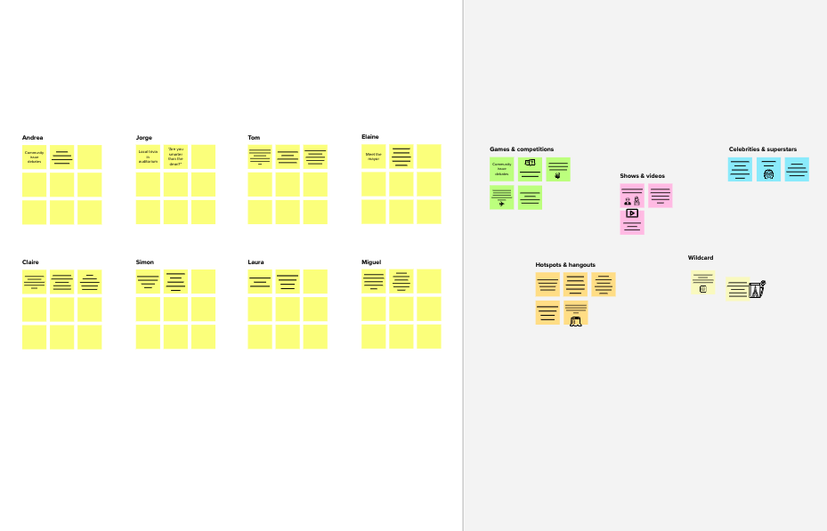

# Feasibility

[**Share template feedback**](https://muralco.typeform.com/to/CiqaHVat?typeform-source=app.mural.co)

###### Regardless of their importance, which tasks are more feasible than others? (Cost, time, effort, complexity, etc.)

**Need some inspiration?**

See a finished version of this template to kickstart your work.

[**Open example**](https://app.mural.co/template/e5a93b7b-49f2-48c9-afd7-a635d860eba6/93f1b98d-b2d2-4695-8e85-7e9c0d2fd9b9)

|  |  |  |  |  |
| --- | --- | --- | --- | --- |
|  |  |  |  |  |
|  |  |  |  |  |